Paul Lintilhac

Problem Set 2 – for Professor Davis

Problem 1:

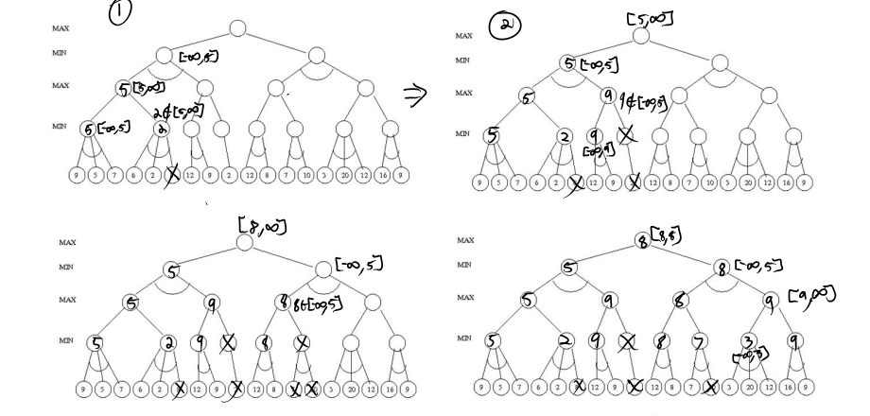

Thus the minimax value at the root node is 8.

Problem 2:

i)

$$A<=>\left(E∪¬F\right)$$

$$\left(A=>\left(E∪¬F\right)\right)∩(\left(E∪¬F\right)=>A)$$

$$\left(¬A∪\left(E∪¬F\right)\right)∩\left(A∪¬\left(E∪¬F\right)\right)$$

$$\left(¬A∪E∪¬F\right)∩\left(A∪\left(¬E∩F\right)\right)$$

$$\left(¬A∪E∪¬F\right)∩(A∪¬E)∩\left(A∪F\right)$$

ii)

$$A=>\left(B∪F\right)$$

$$\left(B∪F\right)∪¬A$$

$$B∪F∪¬A$$

iii)

$$B=>\left(E=>C\right)$$

$$B=>\left(C∪¬E\right)$$

$$\left(C∪¬E\right)∪¬B$$

$$C∪¬E∪¬B$$

iv)

$$B=>\left(E∪F\right)$$

$$\left(E∪F\right)∪¬B$$

$$E∪F∪¬B$$

v)

$$C=>D$$

$$D∪¬C$$

vi)

$$E=>¬\left(D∩F\right)∩B$$

$$\left(¬\left(D∩F\right)∩B\right)∪¬E$$

$$\left(\left(¬D∪¬F\right)∩B\right)∪¬E$$

$$(¬E∪ B)∩\left(¬E∪¬D∪¬F\right)$$

vii)

$$E=>\left(¬B∪F\right)$$

$$\left(¬B∪F\right)∪¬E$$

$$¬B∪F∪¬E$$

Problem 3:

Our clauses in CNF are:

$$\left(¬A∪E∪¬F\right)∩(A∪¬E)∩\left(A∪F\right)$$

$$B∪F∪¬A$$

$$C∪¬E∪¬B$$

$$D∪¬C$$

$$(¬E∪ B)∩\left(¬E∪¬D∪¬F\right)$$

$$¬B∪F∪¬E$$

Starting with A=TRUE, we have: $$\left(E∪¬F\right)$$

$$B∪F$$

$$C∪¬E∪¬B$$

$$D∪¬C$$

$$(¬E∪ B)∩\left(¬E∪¬D∪¬F\right)$$

$$¬B∪F∪¬E$$

Next, we choose B=TRUE:

$$\left(E∪¬F\right)$$

$$C∪¬E$$

$$D∪¬C$$

$$\left(¬E∪¬D∪¬F\right)$$

$$F∪¬E$$

Next, C=TRUE:

$$\left(E∪¬F\right)$$

$$D$$

$$\left(¬E∪¬D∪¬F\right)$$

$$F∪¬E$$

Now D=TRUE because it is a singleton:

$$\left(E∪¬F\right)$$

$$\left(¬E∪¬F\right)$$

$$F∪¬E$$

So we try E=TRUE:

$$\left(¬F\right)$$

$$F$$

Thus this set of values is not satisfiable.

Instead we try E=FALSE:

$$\left(¬F\right)$$

$$F$$

Not satisfiable.

Therefore we backtrack. Since D was a singleton, we must go all the way back to C=FALSE:

$$\left(E∪¬F\right)$$

$$¬E$$

$$\left(¬E∪¬D∪¬F\right)$$

$$F∪¬E$$

D is a singleton and therefore must be false:

$$\left(E∪¬F\right)$$

$$¬E$$

$$F∪¬E$$

Now E is a singleton so it must be false:

$$\left(¬F\right)$$

And thus F=FALSE

Therefore the sentence is satisfied when

A=TRUE

B=TRUE

C=FALSE

D=FALSE

E = FALSE

F=FALSE